SPARK: Simple Play Adaptations to Reference for Kids

Communication Board Protector
Description: | Image:
Add durability to paper communication boards by inserting them into this plastic sleeve. Great for the communicator on the go, this plastic protector fits one 8.5” × 11” sheet of paper and features pockets on both sides. This product fits easily in backpacks and folders and is lightweight, so it can be used in the hallway, in the car and even at the park! | 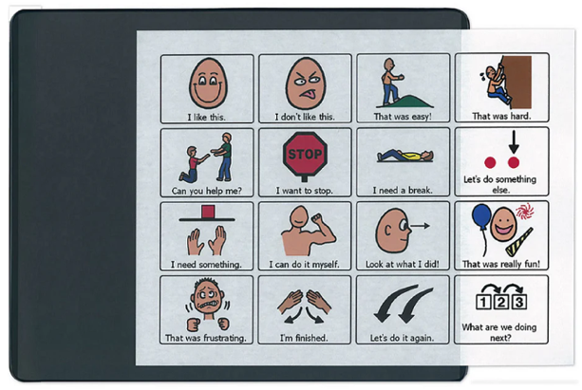  Purchasing Information
Who Might Benefit?
Those who…
• Need symbol support to express or receive information.
• Grip pages tightly causing them to become rumpled or torn.
• Are engaged in messy play or eating, preventing communication pages from spillage.
Why Use?
Provides an opportunity to…
• Communicate with partners in many locations, especially in those not suitable for a more complex communication system.
• Have a wide variety of communication symbols available on 8.5” x 11” sheets of paper.
• Have a paper-based communication system protected by a plastic sleeve and reinforced by a study backing preventing communication pages from becoming smeared or torn.
Instructions for Use: | Adaptation Ideas:
Environmental Considerations  - Easily use in almost any environment because of the small size, weight, and easy transportability.  - If this particular style of communication is selected, make sure it is available is all child’s customary environments (e.g. home and school) to provide structure and routine, improve understanding, avoid frustration and offer opportunities to interact with others.  Positioning  - Use in most any position due to the size, portability, and minimal weight. It can be used on a table top, placed on the floor, positioned on a slant board, etc. A child could use it in positions such as sitting, standing, prone (Tummy Time position), supine (laying on their back), kneeling, etc. Provide at optimal viewing level and ensure its within reach of the child.  Basic Play/Use  - Introduce Communication Board Protector with added symbol/visual support pages to the child and explain what you are going to be using it for.  - Be consistent in the use of visuals.  - Make accessible to everyone supporting the child (e.g. have a specific area for keeping it) and make sure everyone knows where it is.  Extended Play/Use  - Model use of communication boards. | Optional Additional Materials/Supplies  - Velcro  - Sheet protectors  - Gallon size ziplock bags  - 3-ring binders with clear view covers  - Duct tape  - Clipboard  Build It Up  - Build up edges for easy gripping or to provide high contrast.  Simplify It  - Start with only a few photos or visual symbols on each page based on the child's ability to understand and select responses, adding more as needed.  Stabilize It  - Velcro to various surfaces in the environment as needed so it does not shift while the child is attempting to access it.  Add Sensory Cues  - Consider using high contrast visuals and/or contrasting background.  - Cut around the shapes of the visuals selected to be displayed and glue to high contrast background (ex: yellow or black paper).  Alternative Uses  - Can be used to display schedules, task sequences, etc.  DIY Alternatives  - Place communication pages in a sheet protector with a piece of thin cardboard backing between the front and back pages.  - Place communication pages in a gallon-sized ziplock bag. Insert a piece of thin cardboard backing between the front and back pages, trimming as needed, and zip closed.  - Use a one inch binder with a clear view cover to display communication pages. Additional communication pages can be stored inside. One inch spine offers a slight slant which may benefit viewing.  - Cut the covers off or 3 ring binders with clear view covers and insert communication pages.

Resources:
- How to create low tech communication pictures
- Examples of good high contrast color schemes for low vision and why they are important

Note: Research has shown that early use of a communication device does not impact a child’s ability to develop oral speech later and will actually often help to enhance development of oral speech. See: Beyond Spoken Words :Augmentative and Alternative Communication (AAC).

